Possessive Attribute

✅ What is Possessive Attribute?
# Source: AI Source: Provided by: [Data Path: Persons Table -> ID Column: 1, Name_En Column: Motasem Essam] -> From: [Chatgpt (GPT‑5 Mini)] on [8/7/2025]
A Possessive Attribute is a word or phrase that shows ownership or association and functions as a modifier of a noun. It typically answers the question “whose?”

🔹 Key Features:
# Source: AI Source: Provided by: [Data Path: Persons Table -> ID Column: 1, Name_En Column: Motasem Essam] -> From: [Chatgpt (GPT‑5 Mini)] on [8/7/2025]
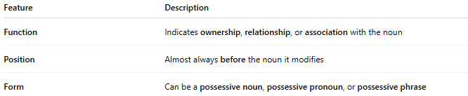
Feature | Description
Function | Indicates ownership, relationship, or association with the noun
Position | Almost always before the noun it modifies
Form | Can be a possessive noun, possessive pronoun, or possessive phrase

🔹 Forms of Possessive Attributes:
# Source: AI Source: Provided by: [Data Path: Persons Table -> ID Column: 1, Name_En Column: Motasem Essam] -> From: [Chatgpt (GPT‑5 Mini)] on [8/7/2025]
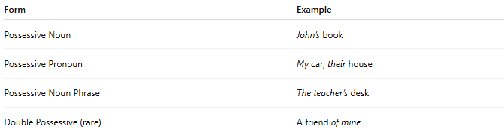
Form | Example
Possessive Noun | John’s book
Possessive Pronoun | My car, their house
Possessive Noun Phrase | The teacher’s desk
Double Possessive (rare) | A friend of mine

🔹 Examples in Sentences:
# Source: AI Source: Provided by: [Data Path: Persons Table -> ID Column: 1, Name_En Column: Motasem Essam] -> From: [Chatgpt (GPT‑5 Mini)] on [8/7/2025]
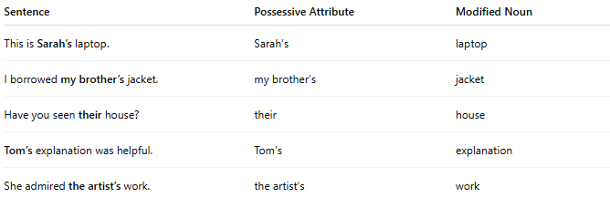
Sentence | Possessive Attribute | Modified Noun
This is Sarah’s laptop. | Sarah’s | laptop
I borrowed my brother’s jacket. | my brother’s | jacket
Have you seen their house? | their | house
Tom’s explanation was helpful. | Tom’s | explanation
She admired the artist’s work. | the artist’s | work

🔹 Quick Comparison:
# Source: AI Source: Provided by: [Data Path: Persons Table -> ID Column: 1, Name_En Column: Motasem Essam] -> From: [Chatgpt (GPT‑5 Mini)] on [8/7/2025]
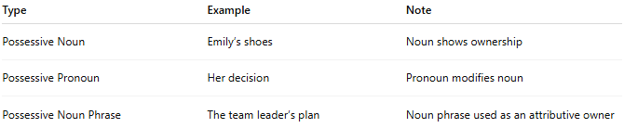
Type | Example | Note
Possessive Noun | Emily’s shoes | Noun shows ownership
Possessive Pronoun | Her decision | Pronoun modifies noun
Possessive Noun Phrase | The team leader’s plan | Noun phrase used as an attributive owner

